Promoted for and behalf of Cycling Time Trials under their rules and regulations
Sussex Cyclists’ Association
Founded 1921

25 Mile Time Trial – Sunday 8th May 2022 – Course G25/93
Incorporating Sussex 25 miles Championship

Event Secretary Timekeepers
Steve Dennis (East Grinstead CC) Start: Mr Mick Irons (Worthing Excelsior CC)
15 Sherwood Walk, Crawley, W. Sussex Finish: Mr Richard Blackmore (East Grinstead CC)
RH10 6NQ
Tel: 01293 522721 – Mob: 07778 548979
E-mail: carla.dennis@sky.com

Prizes

1st Overall £40 1st Lady £40
2nd Overall £30 2nd Lady £30
3rd Overall £20

1st Vet on CTT Target Times £20 1st Team of Three £10 each
2nd Vet on CTT Target Times £15

Sussex Championship awards for affiliated riders

Fastest overall Boniface Cup. Highest plus on CTT target time Horry Hemsley Cup. Fastest team of three Lee Memorial Shield. Medals are also awarded to each team member and individual riders in the following categories: Overall, Veteran on CTT Target Times, Women, Juniors and Juveniles subject to the number of entries in each category. All Championship trophies and medals will be presented at the Annual Prize Presentation Lunch.

Headquarters

Steyning Centre Fletcher’s Croft, Steyning, BN44 3XZ
Open from 6:00 am.

OS Landranger sheet 198, grid ref TQ178 113
Google Maps Streetview link http://goo.gl/maps/hkLKe

Directions and car parking

Coming from the north: A24 / A283 Coming from the South: A27 / A283.
Turn right into Horsham Road and proceed on to Second left off Bramber roundabout. Proceed up Clays
Steyning High Street. At the mini roundabout turn left Hill and continue on to Steyning High Street. At the mini
(NE) and proceed along Church Street pass the library & roundabout turn right (NE) and proceed along Church
church, turn right into Steyning Centre. Street pass the library & church, turn right into Steyning
Centre.

Ample car parking is available at the Steyning Centre
Please do not wear cleated cycling shoes in the Hall. Thank you.
Promoted for and behalf of Cycling Time Trials under their rules and regulations
Sussex Cyclists’ Association
Founded 1921

25 Mile Time Trial – Sunday 8th May 2022 – Course G25/93
Incorporating Sussex 25 miles Championship

Race Numbers Warming up and to the Start

Numbers will be available at the event HQ. Please Competitors are requested not to warm up on the course
collect your number when you sign on. after the event has started.

Notice of any additional hazards to be aware of on the Left out of the car park to the mini roundabout, then right
course will be displayed next to the signing on sheet. onto the High Street. Proceed North to the A283 junction.

After the event please return your race number to the Left and then immediate right on to B2135 for 0.4 miles.
event HQ in exchange for a cup of tea or coffee.

REMEMBER TO SIGN OUT AFTER YOUR RIDE!

.
Please pay attention to the following Safety Notes

London South District Regulation: No vehicles, except those of the timekeepers and race officials, shall be parked in the vicinity of the start or finish areas.

CTT regulations require that all competitors must wear a properly affixed helmet which must be of hard/soft shell construction. Helmets should conform to internationally accepted safety standards.

Competitors Machines: must have working front and rear lights, either flashing or constant, fitted to their machine in a position clearly visible to other road users and is active while the machine is in use.

Please be aware that there has been road works on the course, and the event may have to use an emergency course.

Course details G25/93 Distance

START on B2135 just south of entrance to Wappingthorpe Manor (Map ref TQ 172131). 0.0

Proceed north on the B2135 through Partridge Green to junction with A24. (M) 6.708

Turn left and proceed southwards on the A24 to Washington RBT. (M) 12.519

Turn left on A283 and proceed east, via Bramber and Beeding Court RBT (M) to Turn at Adur
Bridge RBT.(M) 20.987

Retrace on A283 via Beeding Court and Bramber RBTs to Finish at paint mark on curb opposite
TP3 about 25 yards before Canons Way. (Map ref TQ 181118). 25.00

Course details can be viewed or downloaded from the SCA website at the link www.sussexca.org.uk/g2593.html

Promoted for and behalf of Cycling Time Trials under their rules and regulations
Sussex Cyclists’ Association
Founded 1921

25 Mile Time Trial – Sunday 8th May 2022 – Course G25/93
Incorporating Sussex 25 miles Championship

TIME TRIAL COURSE - G25/93
Steyning - Partridge Green - West Grinstead - Washington - Shoreham - Steyning - A24 / A283 - B2135
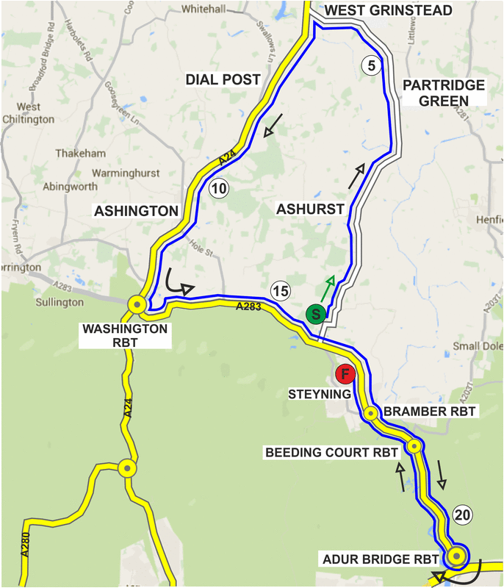

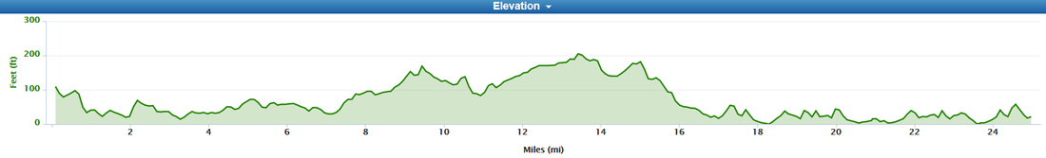

No. | Name | Club | Cat. | Standard | Start
 |  |  |  | Time | Time
15 | Joe Benians | Lewes Wanderers CC | S |  | 07:15
16 | Collin Toppin | Worthing Excelsior CC | V49 | 1:06:45 | 07:16
17 | Katie Simmonds | Horsham Cycling | W |  | 07:17
18 | Henry Weaver | Southborough & Dist. Wheelers | Jun16 |  | 07:18
19 | Tom Brewerton | Crawley Wheelers CC | S |  | 07:19
20 | David Clark | Eastbourne Rovers CC | V53 | 1:08:45 | 07:20
21 | James Stone | Brighton Excelsior CC | V53 | 1:08:45 | 07:21
22 | Karl Roberton | Worthing Excelsior CC | V47 | 1:05:47 | 07:22
23 | John Marchment | HuntBikeWheels.com | V70 | 1:17:51 | 07:23
24 | Andrew Lock | Worthing Excelsior CC | V55 | 1:09:45 | 07:24
25 | Sally Turner | Trainsharp | WV42 | 1:07:15 | 07:25
26 | John Marinko | Brighton Mitre CC | V57 | 1:10:47 | 07:26
27 | Oliver McDonald | Tuff Fitty Tri Club | S |  | 07:27
28 | Clive Patterson-Lett | Worthing Excelsior CC | V56 | 1:10:16 | 07:28
29 | Paul Tippett | Crawley Wheelers CC | V48 | 1:06:16 | 07:29
30 | Nik Allen | Team TMC | V50 | 1:07:15 | 07:30
31 | Jack Smith | Brighton Mitre CC | S |  | 07:31
32 | Donald Parker | Brighton Mitre CC | V73 | 1:19:35 | 07:32
33 | Emma O’Toole | Nopinz Motip RT | W |  | 07:33
34 | Peter Horsfield | Redmon CC | V71 | 1:18:26 | 07:34
35 | Kevin Plummer | Team TMC | V56 | 1:10:16 | 07:35
36 | Ed Jarman | Brighton Excelsior | V44 | 1.04:21 | 07:36
37 | Paul Newsome | Project 51 | S |  | 07:37
38 | Ben Hardisty | East Grinstead CC | V63 | 1:13:58 | 07:38
39 | Tracy Williams | Brighton Mitre CC | WV53 | 1:12:21 | 07:39
40 | Matthew Smith | Team TMC | S |  | 07:40
41 | Ian Cheesman | Worthing Excelsior CC | V53 | 1:08:45 | 07:41
42 | Sam Bennett | 7 Oaks Tri Club | V49 | 1:06:45 | 07:42
43 | Mark Newnham | Worthing Excelsior | V45 | 1:04:50 | 07:43
44 | Anita Turner | Eastbourne Rovers CC | WV51 | 1:11:50 | 07:44
45 | Adrian Blacker | VTTA (Surrey/Sussex) | V58 | 1:11:18 | 07:45
46 | Chris Hewitt | Oxted CC | S |  | 07:46
47 | David Mascall | Norwood Paragon CC | V50 | 1:07:15 | 07:47
48 | Jane Wiley | 7 Oaks Tri Club | WV64 | 1:19:00 | 07:48
49 | Marin Cade | Cranleigh Cycling Club | V50 | 1:07:15 | 07:49
50 | Andrew Meilak | Velo Refined Rule 5 | V55 | 1:09:45 | 07:50
51 | Paul Thatcher | Brighton Mitre CC | V58 | 1:11:18 | 07:51
52 | Adam Rogers | Eastbourne Rovers CC | V47 | 1:05:47 | 07:52
53 | Glen Whittington | Southborough & Dist. Wheelers | S |  | 07.53
54 | Peter Owen | Norwood Paragon CC | V61 | 1:12:53 | 07:54
55 | Steven Kane | Team TMC | S |  | 07:55
56 | Richard Tully | Elite Cycling | V45 | 1:04:50 | 07:56
57 | Brandon Stott | Epsom CC | V48 | 1:06:16 | 07:57
58 | Rick Hughes | Worthing Excelsior CC | V59 | 1:11:50 | 07:58
59 | Tony Reeves | GS Stella | V50 | 1:07:15 | 07:59
60 | Pat Wright | Paceline RT | S |  | 08:00
 |  | Sponsored Clubs
 | Trainsharp | Elite Cycling/Elitecycling Turbo Beat

